User Manuel

# Running the application

Click on the program with the application logo that looks as follows:

# Application

To connect to server:

1. Enter custom IP and Port. To save custom

additionally select the save option. Then

click connect

OR

1. Select from active (previously stored)

servers and click connect

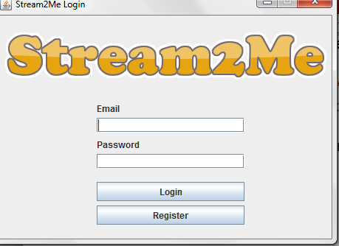

## To Login:

Enter username and password, click

Login

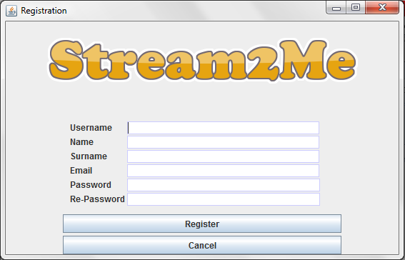

## To Register:

Click Register on the Login page.

Enter details into fields.

Click Register

# User Interface

1

6

2

7

3

3

8

4

5

1. Start Video Stream (see Streaming)
2. Start Audio Stream (see Streaming)
3. Hide Controls or Message/Profile
4. Settings
5. Logout
6. User Card
7. Messages
8. Contact Card

## Streaming

1. To invite a Contact to a stream. Start the stream, Right click the contact and select invite to stream
2. To remove a Contact from a stream. Right click the contact and select remove from stream
3. To stop stream. Click stream button again

## Settings

Allows switching between groups.

### To leave a group:

1. Click leave group.
2. Click join group.
3. Select a new group to join.

Default group uses blank password.

Leaving will not be valid until a new group has been successfully joined

### To create a group:

1. Click leave group
2. Click create group
3. Enter name and password of new group
4. Click create group.

## User card

The current logged in user. Right click to view group Messages or view/edit user profile.

## Contact card

An active user in the same group. Right click view Contact profile, Messages or to invite to audio/video stream or to remove from audio/video

## User Profile

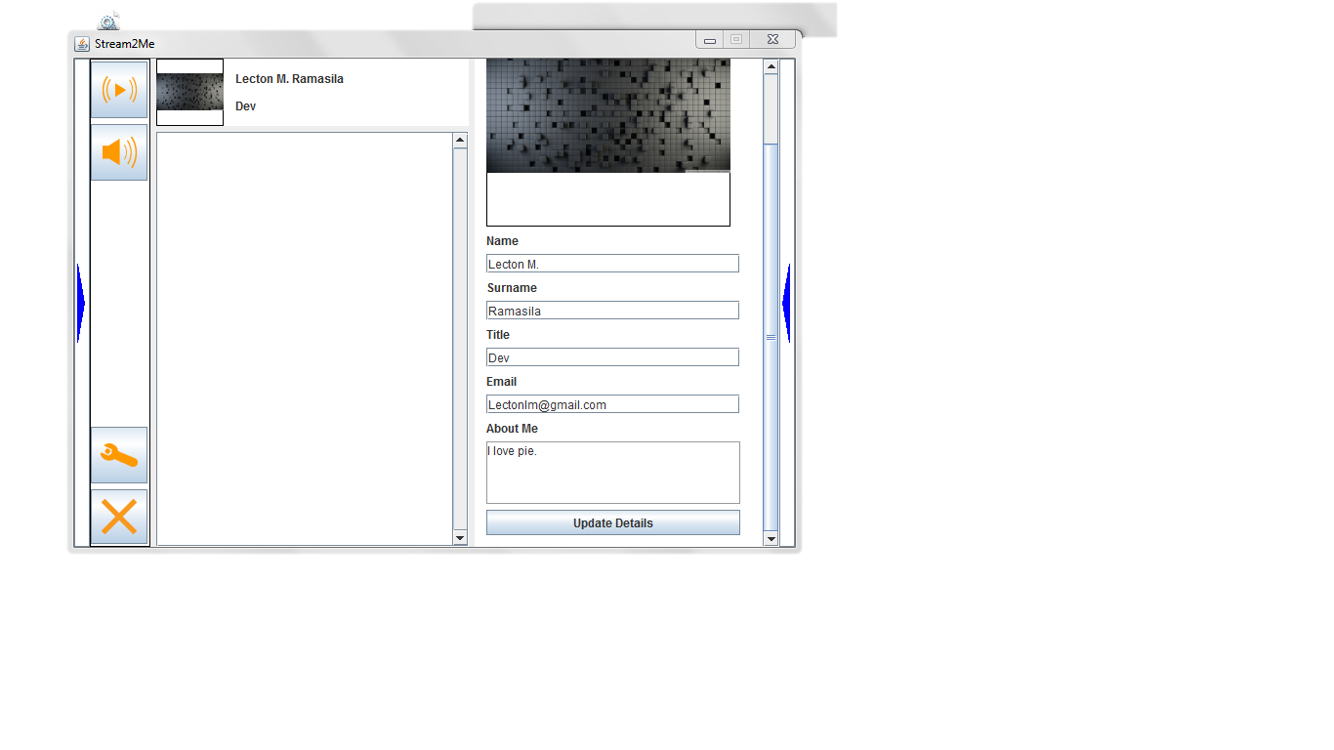

3

1

2

1. Update Avatar

Right click the image and select a new Image. Update will happen automatically

1. Update Profile data

Change details and update them by clicking the update details button.

## Accepting stream

To accept a stream, select the user you are receiving a stream from denoted by an audio or video icon by the Contact card. Once selected buttons will be available on the left hand side to accept or reject audio/video streams. *Location of the buttons is denoted by nr.3 in the User Profile preview.*